|  |
| --- |
| **WEb engineering lab**    **project report**  SUBMITTED TO:  Miss Uzma Zehra  ONLINE SERVICE  PROVIDER  Prepared by:  SYED ALI MEHDI (SE-063)  AYESHA NADEEM (SE-036)  KHADIJA HUSSAIN (SE-030) |



ACKNOWLEDGEMENT

We take this occasion to thank GOD, Almighty for blessing us with his grace and taking our endeavor to a successful culmination. We extend our sincere and heartfelt thanks to our esteemed guide, MISS UZMA ZEHRA, for providing us with the right guidance and advice at the crucial junctures and for showing us the right way and last but not least we would like to thank our group members for the support and encouragement they have given us during the course of work.

Table of Contents

**INTRODUCTION3**

**Why darzi.pk3**

**PROJECT DETAILS**4

**HOME PAGE5**

**NAVIGATION6**

**PLACE AN ORDER**6

**BECOME A DARZI7**

**LOGIN AS DARZI8**

**PROFILE OF DARZI9**

**ORDER FORM10**

**ADMIN LOGIN FORM11**

**SDMIN DASHBOARD12**

**VIEW ALL DARZI13**

**INSERT DARZI14**

**DELETE DARZI15**

**HELP16**

**ABOUT17**

**FOOTER18**

# INTRODUCTION

On Darzi.pk ensures that whatever you wear stands out in the crowd by stitching your favorite dresses out of the best designs from our expert darzis in affordable prices. Help customers stitch the best fit ensemble by our darzis for the customers to walk down the aisle with all the elegance and gleam. Providing many Darzis with full and part time job opportunities to support their families.

Why Darzi.pk???

Our project the ONLINE SERVICE PROVIDER is about to encourage the tailors who does not have their own shop or are not well-known but have ability to stitch some perfect masterpieces.

This on other hand also helps the customer to select darzi of his own choice and can order while sitting at home and also gets the dress in time.



PROJECT DETAILS:

TECHNOLOGIES USED

FRONT END:

* Html
* Css
* Bootstrap
* Javascript

BACK END:

* PHP
* Javascript

DESCRIPTION:

Darzi.pk registers a darzi after authenticating the request of the form that was submitted. The darzi when on board gets his/her separate profile so he she can edit details and also update his design portfolio which will be viewed by public so the customer can pick the best darzi according to their needs .  
The customer can be anyone who wants to take advantage of the online service , he/she will register , view all the darzis that are in the database , view their individual profiles and select a darzi of his/her choice . As soon as the customer places order to a specific darzi, a notification will be generated for the specific darzi profile to view the order placed.

Admin has his own separate account who acts as a moderator between the darzi and customer.

1. Home page

Home page consists of two button “Place an order” and “Become a Darzi”. Which will direct to two new pages. A Jumbotron with brief information. The three different containers having sort introduction of our goals.

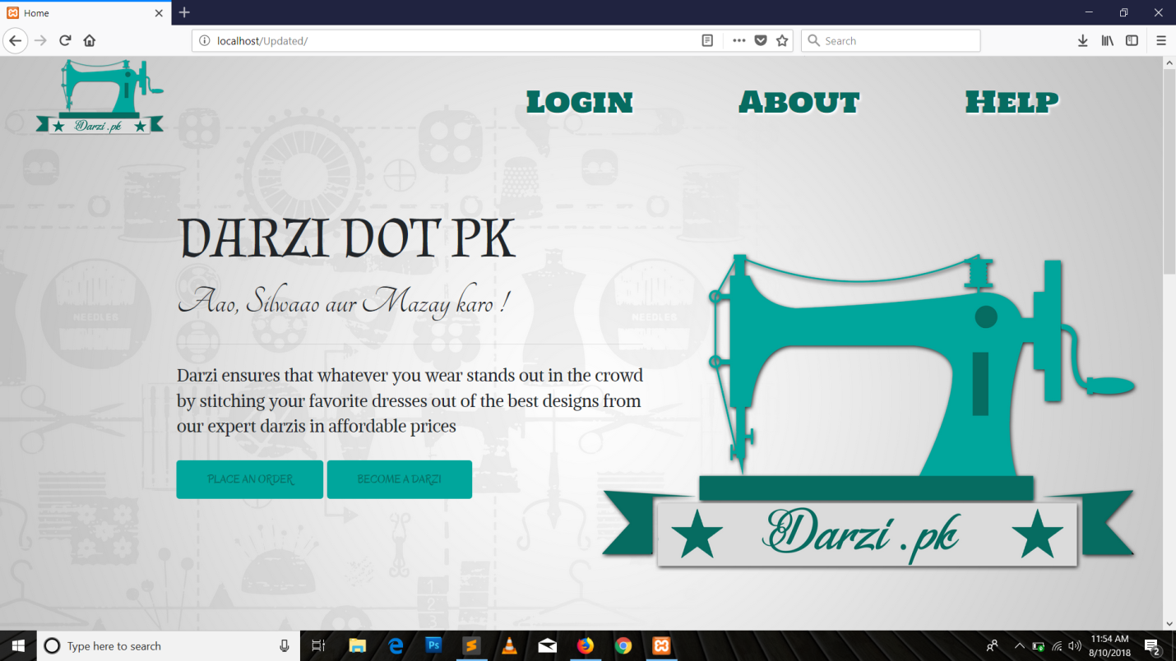

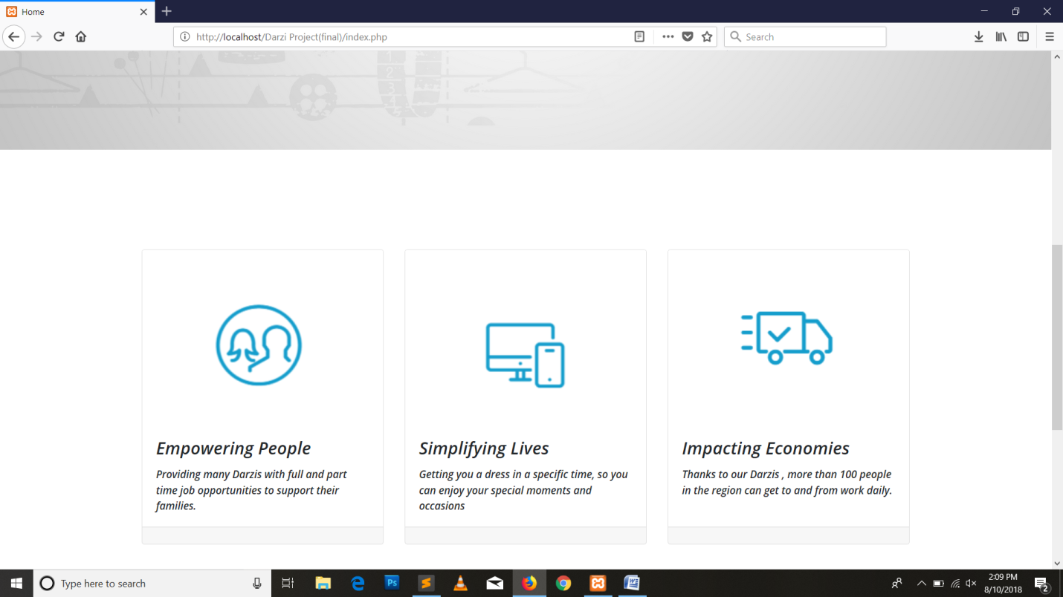

1. Navigation Bar:

Nav bar consists of several links which include the main logo that direct to main home page, Login which direct to login of admin and help and about.



While on hover on any word its color and size will be changed.

1. Place an order:

A common user being customer wishing to contact a darzi while sitting at home can contact a darzi. Customer can choose the darzi of his own choice. He can first view the profile of darzi and can place the order.

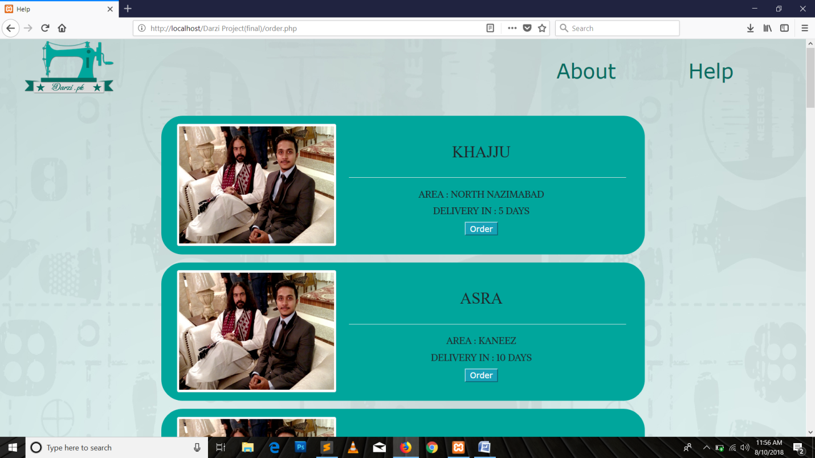

1. Become a darzi:

A page with link consists of a form in person wishing to be a darzi can register him/herself. All fields are mandatory to fill.

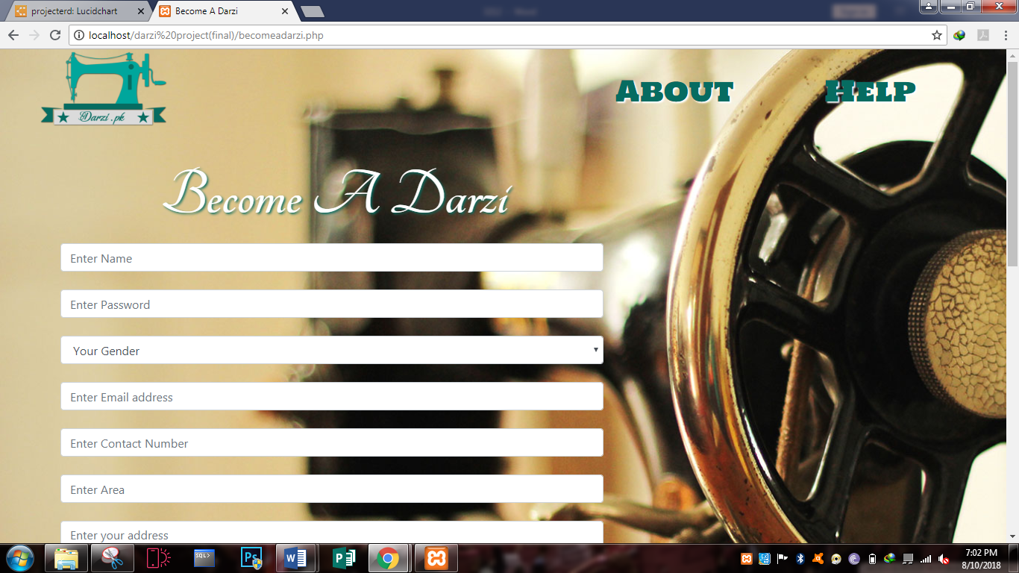

1. Login as Darzi:

Once you become registered you can have your own profile. Profile will contain your basic info and contact details of customer. You can login into it and view if you got any order.

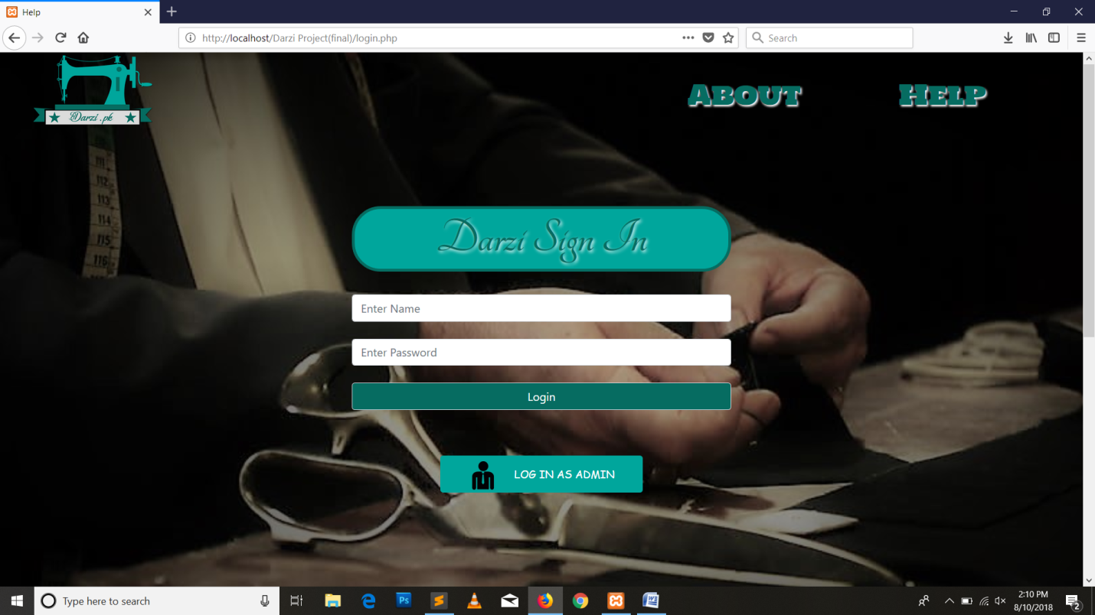

In case of wrong username or password a alert will be popped

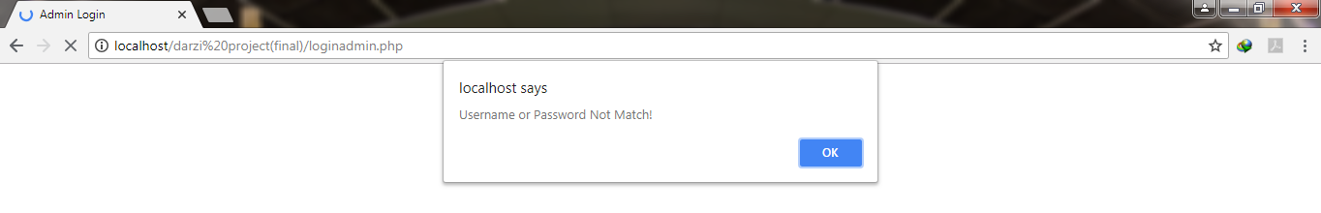

1. Profile of Darzi:

Darzi can view his complete profile and can check the orders placed and check list which ensures that a customer has provide the complete requirement while ordering

to avoid any misunderstandings in future.

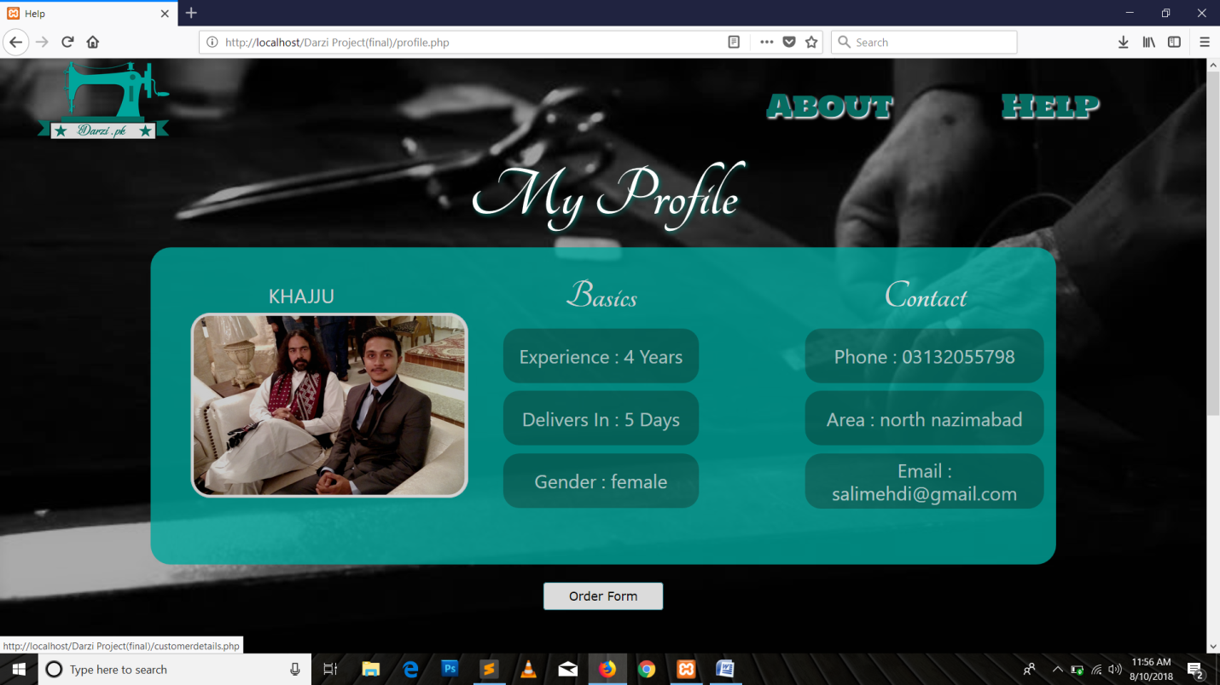

1. Order Form:

Order form will consist of customer details. Customer has to fill the form to ensure that he/she has provided the complete details and stuff to avoid any problem.

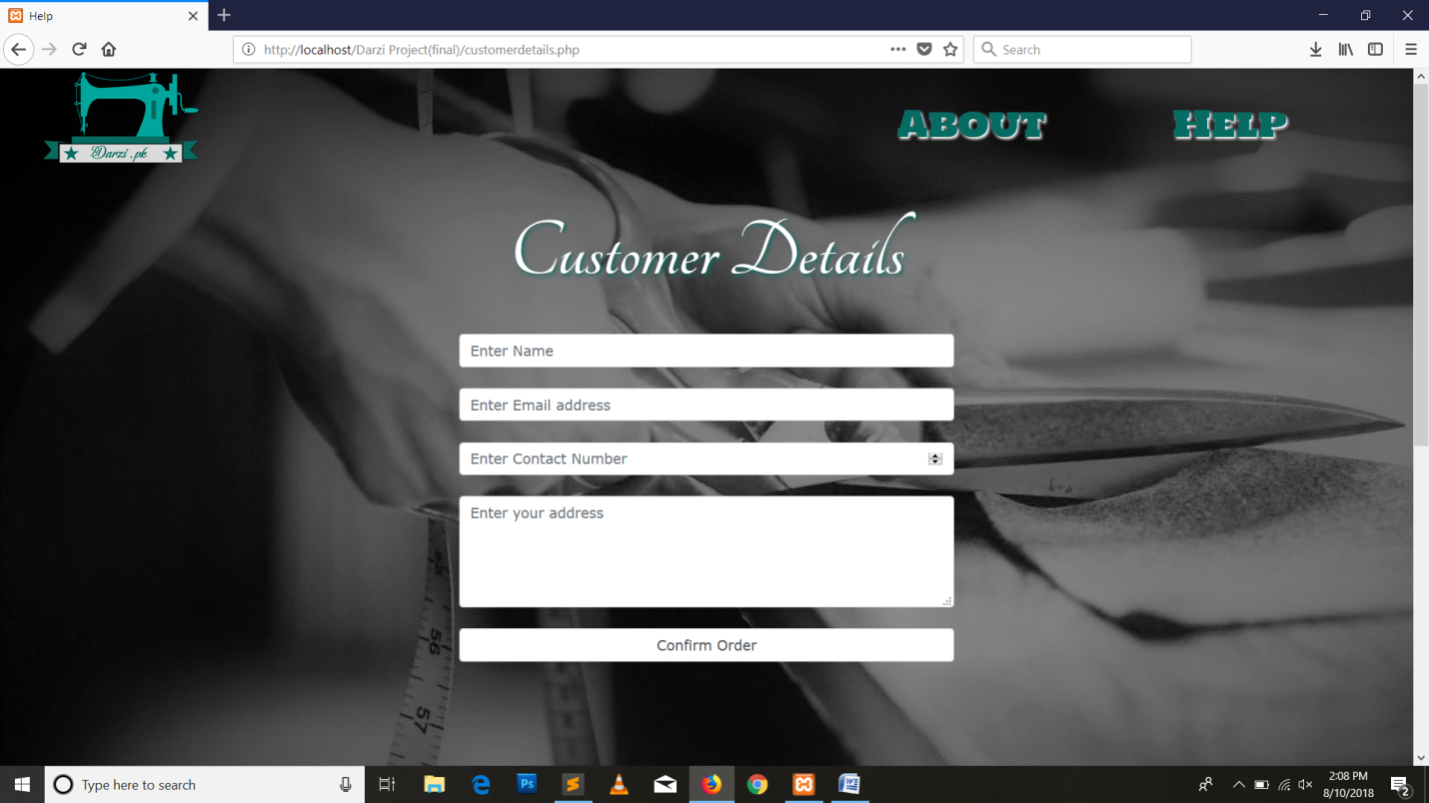

1. Admin login:

Admin of page can logged into his profile while providing correct username and password and can access to his domain.

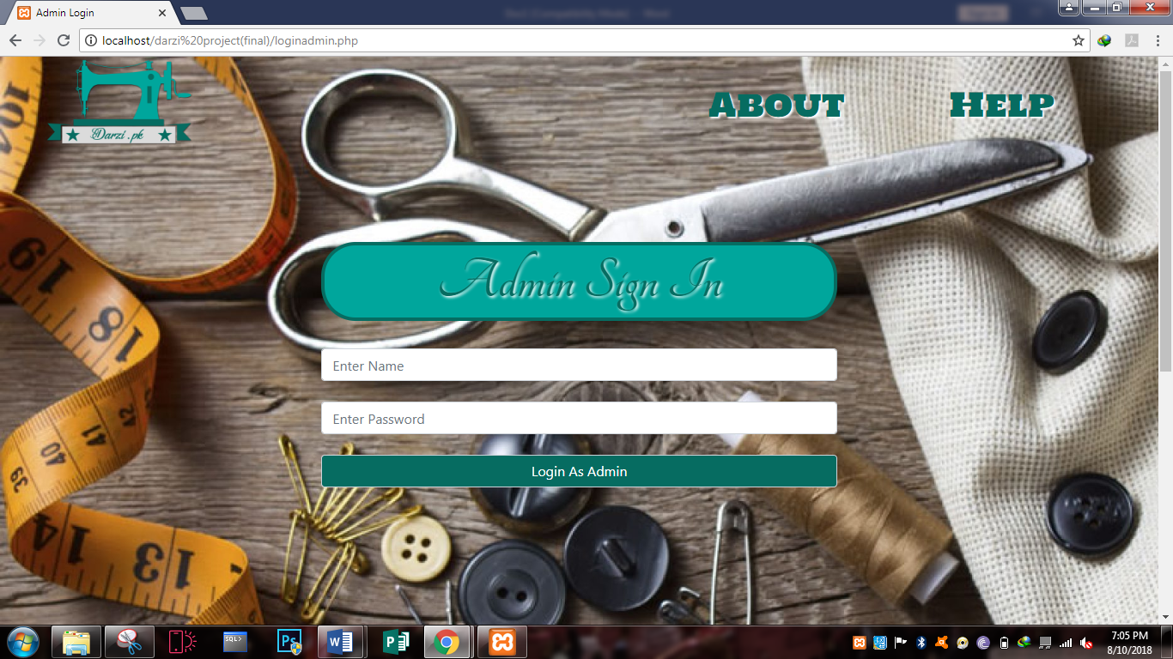

In case of admin username or password is wrong the error message will be generated



1. Admin Dashboard:

Admin has a Proper dashboard with insert, delete and view all darzis. It also includes button to move to home page or logout of session.

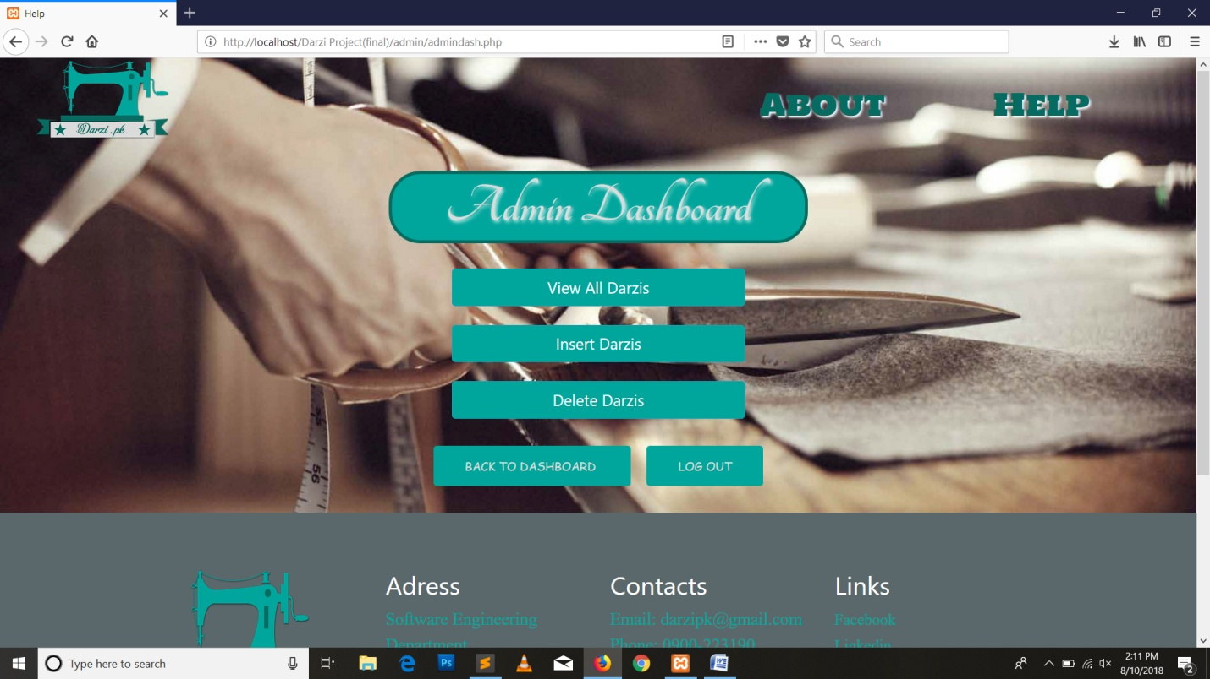

1. View All Darzis:

Admin can view all registered darzi. This page also consists of “logout” and “back to dashboard”. Logout will direct to homepage and oter will go back to admin dashboard.

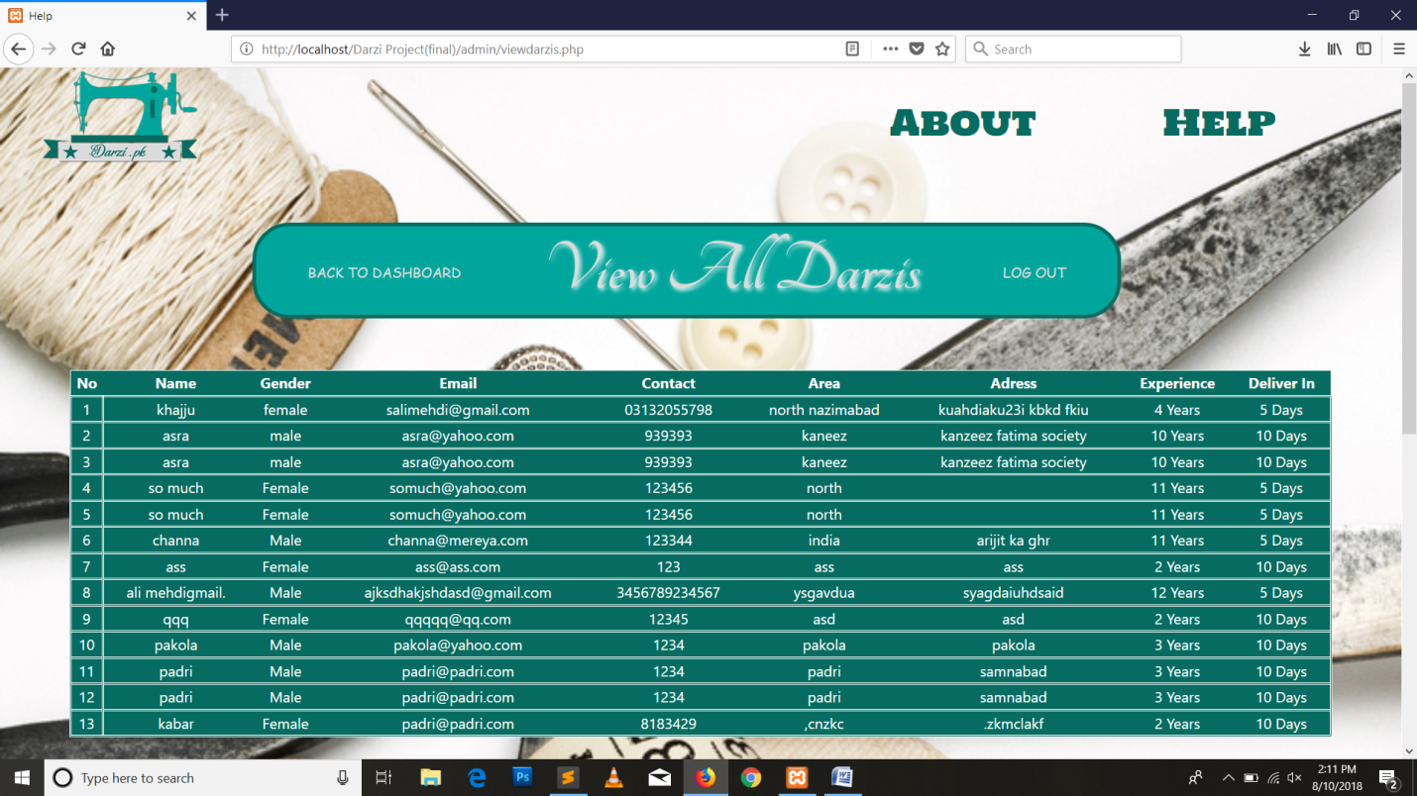

1. Insert a new darzi:

Admin can insert a new darzi. This page also consists of “logout” and “back to dashboard” which will direct admin to either logged out and home page.

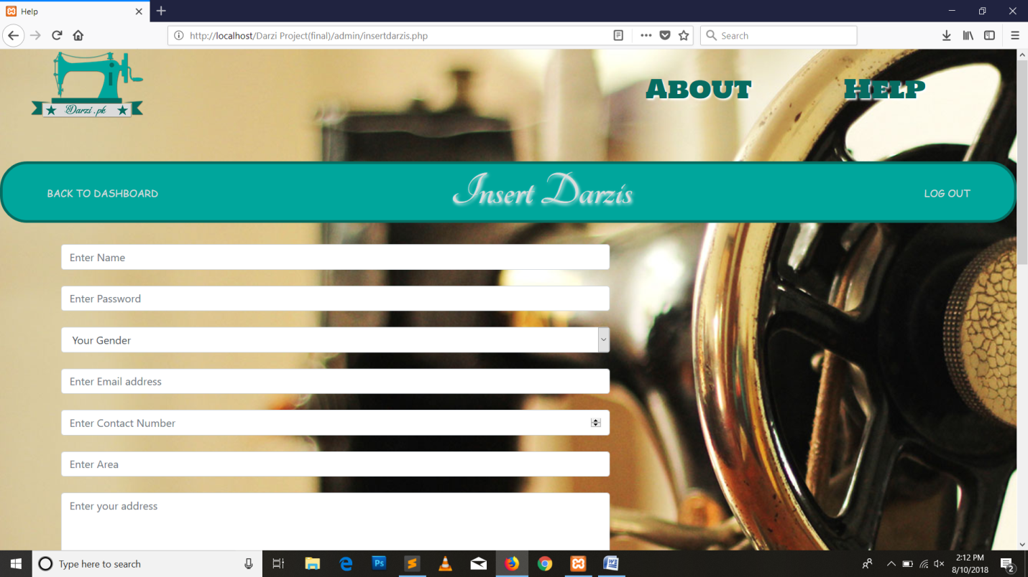

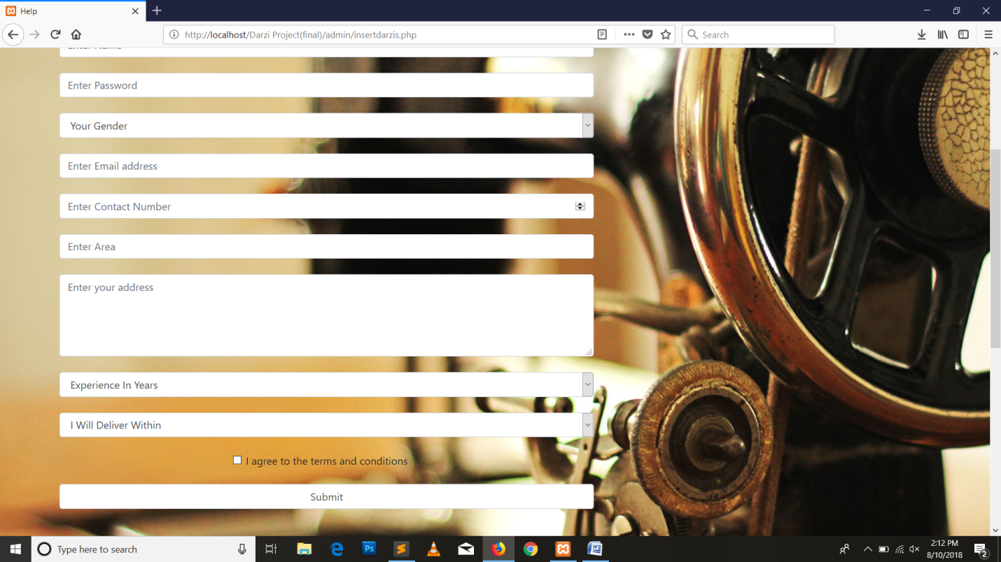

1. Delete a Darzi:

Admin can also delete the darzi in case of any irresponsible behavior. This page also consists of “logout” and “back to dashboard” which will direct admin to either logged out and home page.

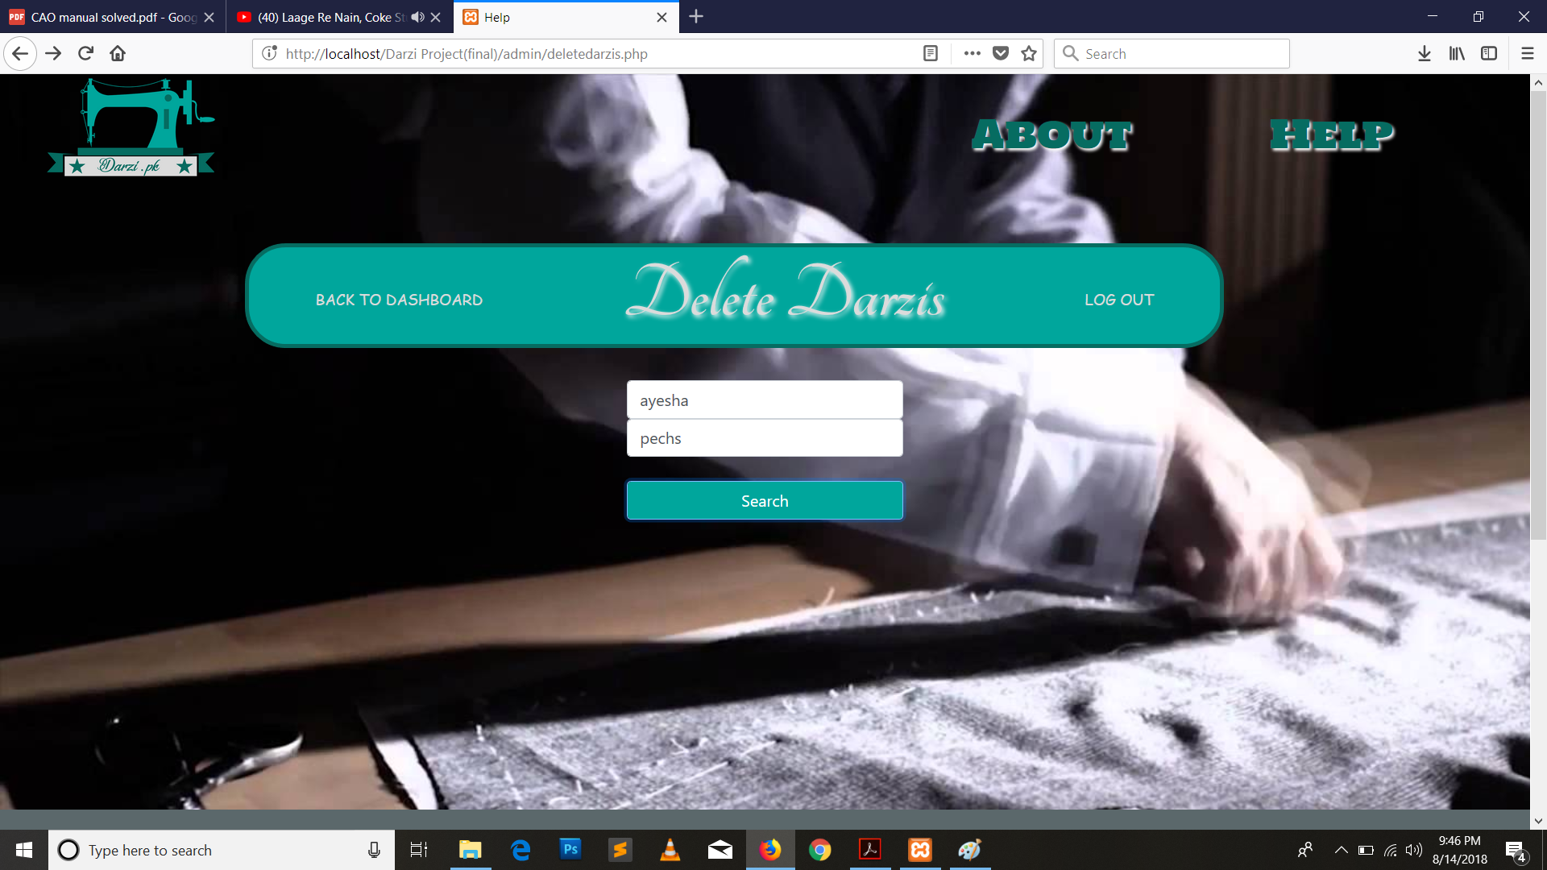

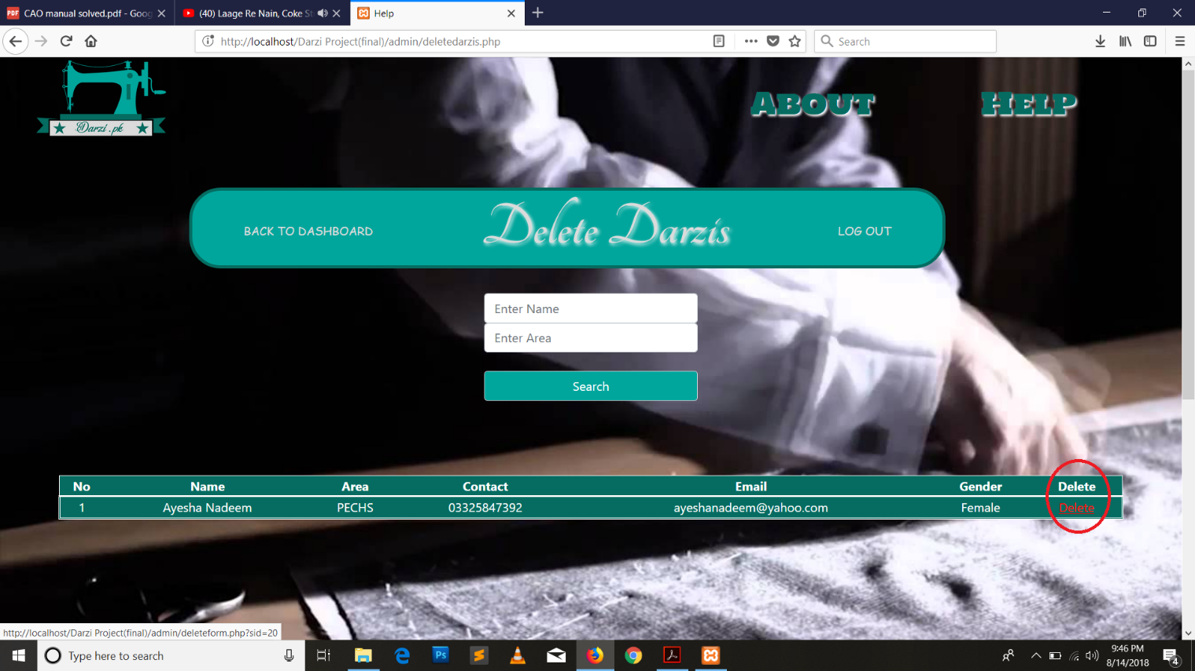

1. Help

Help page consists of an automatic slider and all step by steps instructions for darzi and darzi as well.

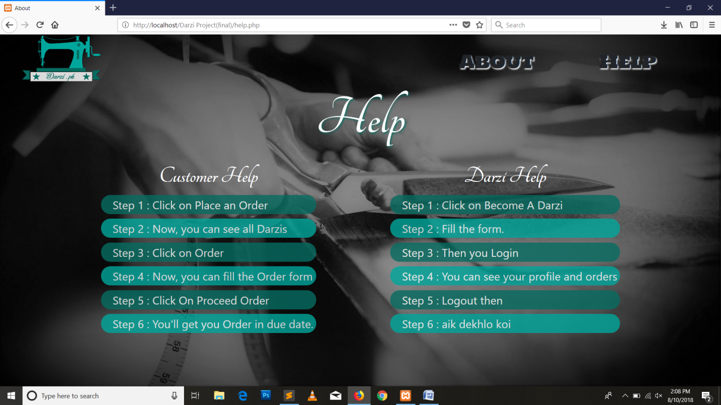

1. About

About page also consists of automatic slider in background and a short paragraph about our project.

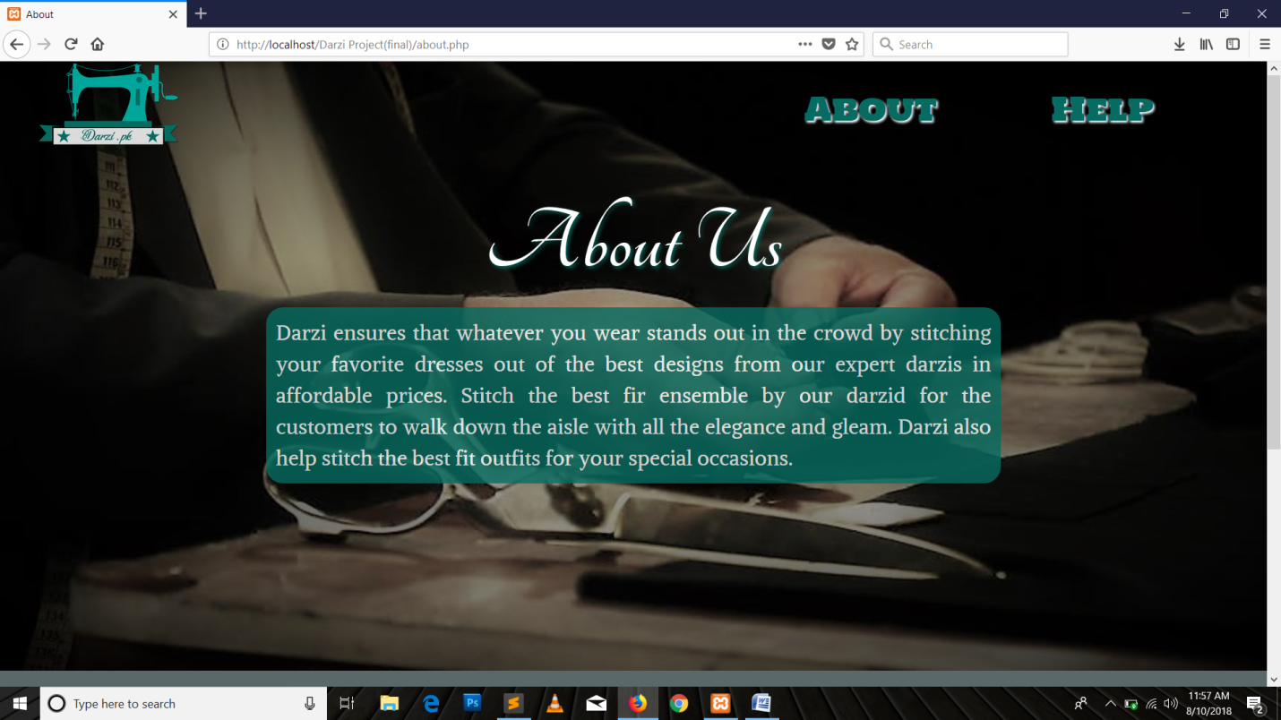

1. Footer

Footer consists of an icon of our website, location, Email, contact information and links of our websites on different social Applications.

